TCP, UDP, Port, IP Address and Network Classes
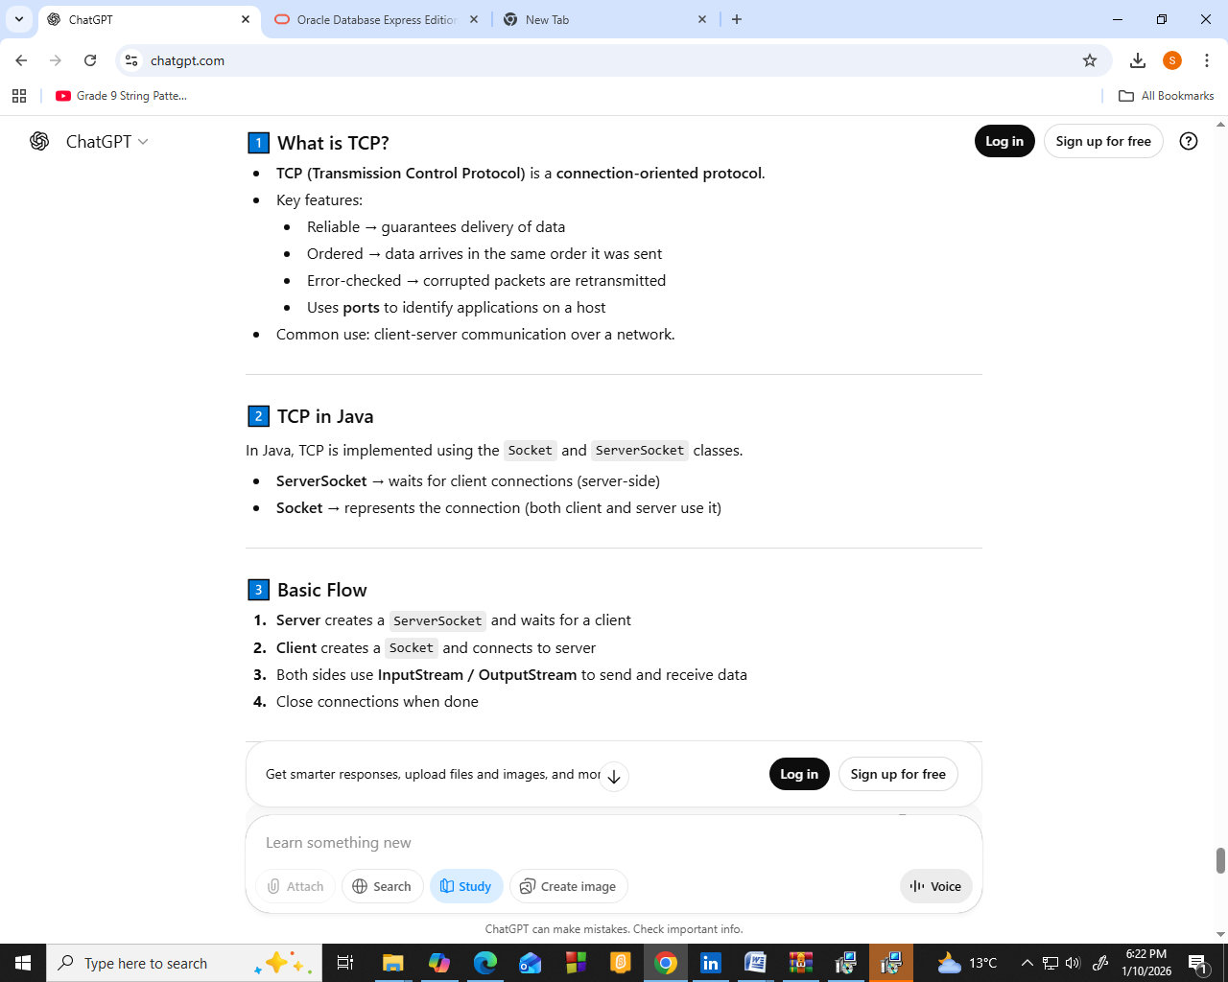

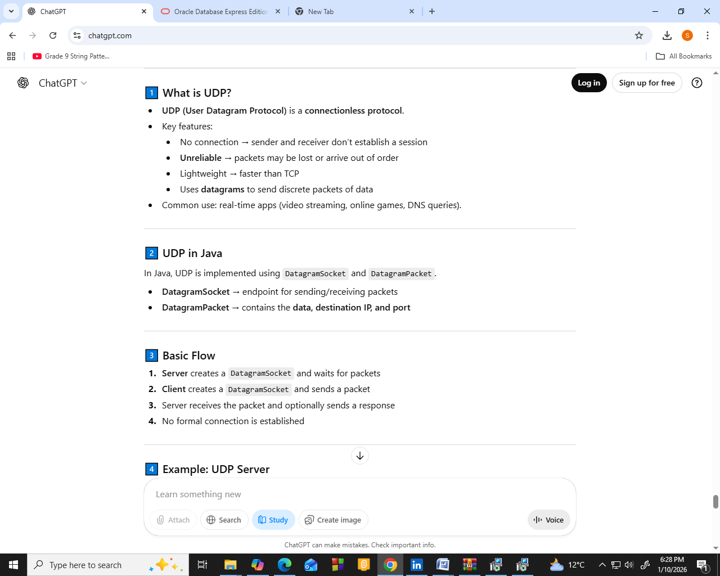

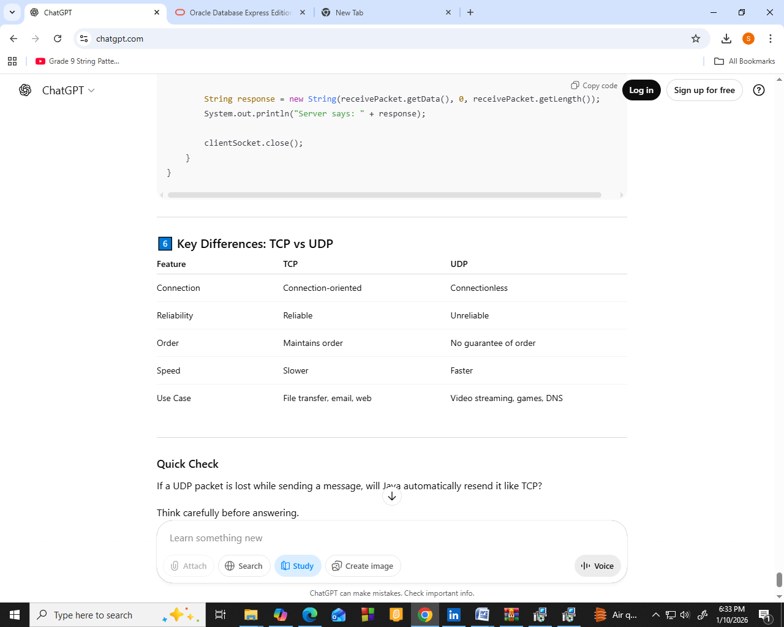

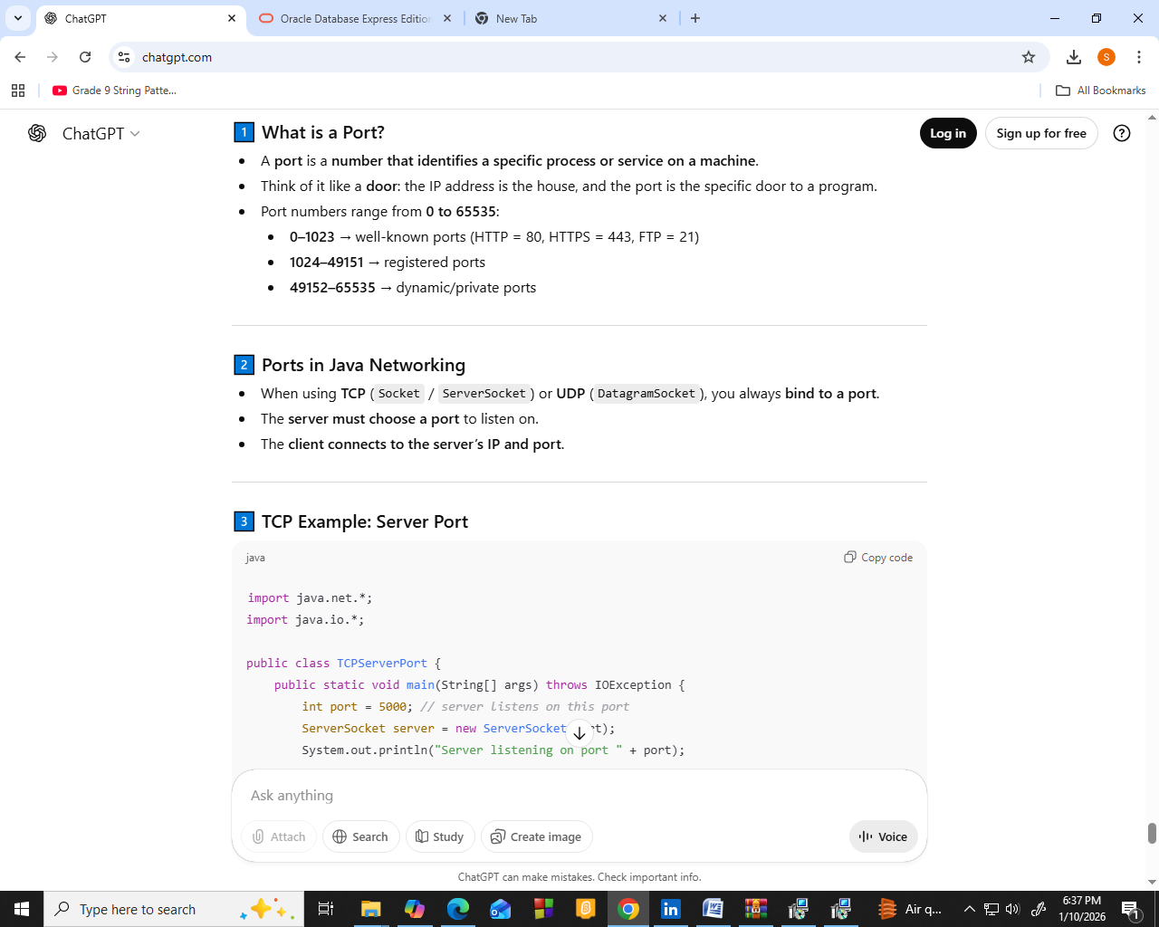
IP Address Network Classes
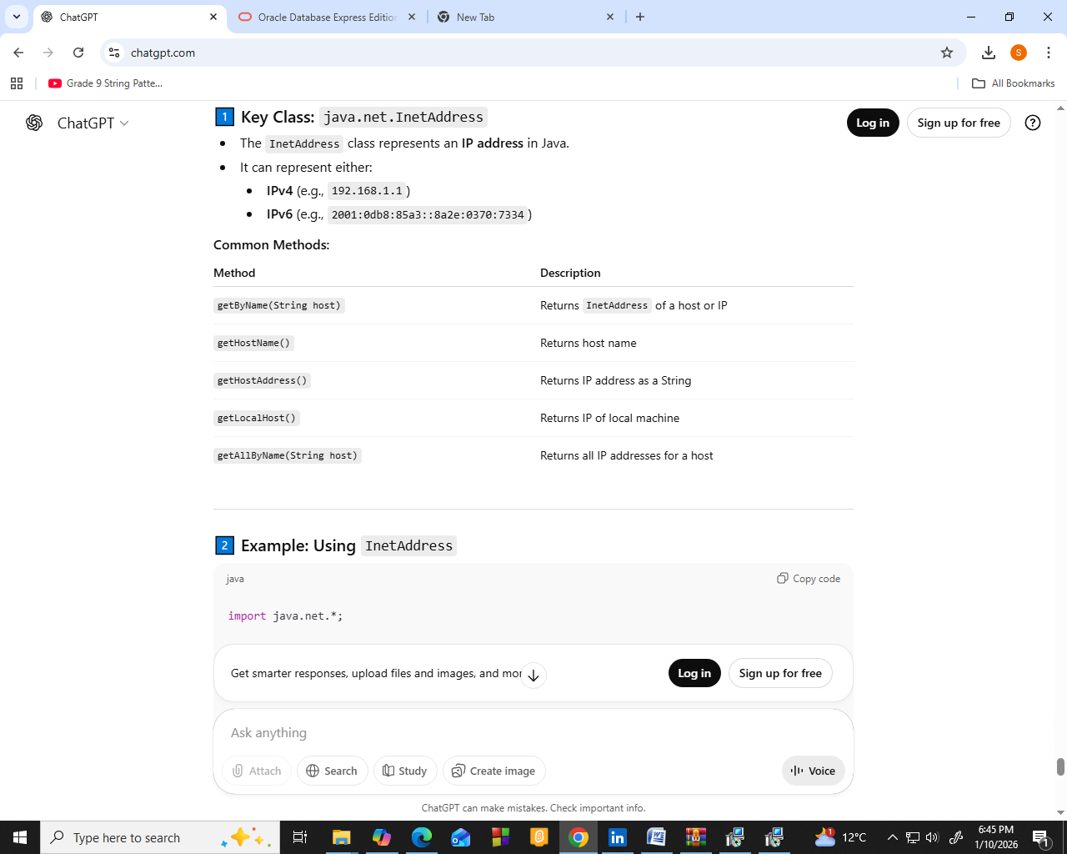
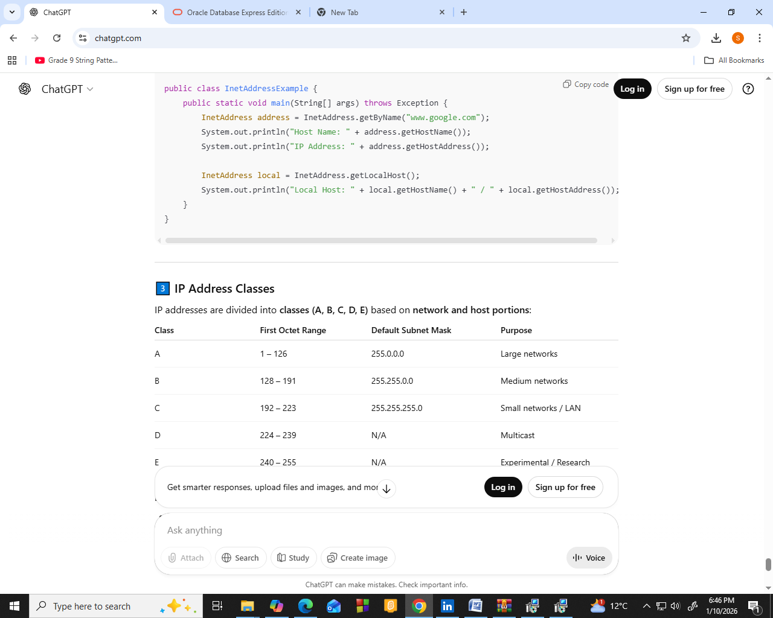
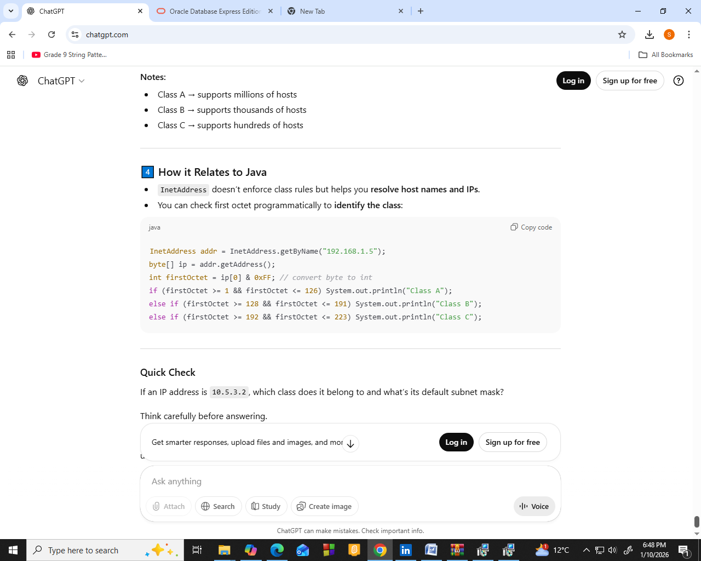
Protocols TCP Ports
HTTP | 80
HTTPS | 443
File Transfer Protocol | 21
Simple Mail Transfer Protocol | 25
MySQL(TCP) | 3306
POP | 110

